|  |
| --- |
|  |

**

**FIRST TERM E-LEARNING NOTE**

**SUBJECT: AGRICULTURAL SCIENCE CLASS: SS3**

**SCHEME OF WORK**

**WEEKS TOPIC**

1. Animal Nutrition (malnutrition)
2. Agricultural Extension

3-4. Fish Farming

5-6. Animal improvement

7. Artificial insemination

8-9. Agricultural financing

10. Agricultural insurance

11. Revision

12. Examination

**REFERENCES**

* Essential Agricultural Science for Senior Secondary Schools by O. A. Iwena
* Fundamental Agricultural Science by P. E. Okafor
* Prescribed Agricultural Science by Omoruyi and Oruhue
* SSCE Agricultural Science pack
* Essential biology for Senior Secondary Schools by M. C. Michael
* Internet (wikipedia, pinterest, youtube, google answer, fao.org etc.)

**WEEK ONE**

**ANIMAL NUTRITION (MALNUTRITION)**

**MALNUTRITION IN FARM ANIMALS**

Malnutrition is said to occur when a ration (amount of feed provided to an animal per day) does not provide all the food nutrients(carbohydrate, protein,fats and oils, vitamins, minerals, water and other feed additives) in adequate quantities. Those nutrients wanting are said to be deficient which eventually results in nutritional disease.

Nutritional deficiency is therefore defined as a disease condition which emanates from inadequate nutrition. It is indicated by specific symptoms when particular nutrients are absent or unavailable in the diet.

The table below shows some nutritional disease, their causes, symptoms and how they can be corrected.

**MALNUTRITION DISEASES OF ANIMALS**

|  |  |  |  |
| --- | --- | --- | --- |
| **MALNUTRITION DISEASE** | **CAUSES** | **SYMPTOMS** | **CORRECTION** |
| Ricket(Osteomalacia) | Lack of Ca,Pand VitaminD | Flexible and curve bones,soft egg shell | Add fish meal,bone meal or Oyster shell |
| Perosis or Slipped tendon. | Lack of choline,folicacid,Ca,P in diet. | Chicken lie down on their Kneel. | Add Vitamin B Co and bone meal. |
| Ketosis | Lack of sufficient energy intake by farm animals | Loss of appetite | Feed CHO to animals. |
| Milk Fever | Low blood sugar. | Loss of appetite, constipation and nervousness. | Feed Oyster Shell, bone meal and Carbohydrate. |
| Baby pig Anaemia | Low iron in blood. | Loss of appetite and nervousness. | Inject iron dextrin into the body. |
| Night Blindness | Lack of Vitamin A | Inability to see clearly in dim light. | Feed yellow maize. |
| Scurvy | Lack of vitamin C | Lesions around the connective tissue. | Feed vegetable and fruits to animals. |
| Beriberi | Lack of VitaminB1 | Lack of appetite, fatigue and loss of weight. | Feed yeast,cereals and vegetables. |

Ricket (osteomalacia):A disease caused by lack of Vitamin D and disappearance of calcium saltswhich prevent the body from using Calcium.Ricket causes softing and sometimes bending of the bones.

Tendon:A tough, strong band or cord of tissue that joins a muscle to a bone or some part and transmits the force of the muscle to the part.

Scurvy: A disease caused by lack of Vitamin C in diet. It’s characterized by swollen and bleeding gums, extreme weakness and livid spots on the skin.

Tetany: A disease characterized by sudden abnormal involuntary contraction of the muscle.

Beriberi: Disease affecting the nervous system accompanied by muscular paralysis,weakness, extreme loss of weight, pain andswelling.It is caused by lack of vitamin B in diet.

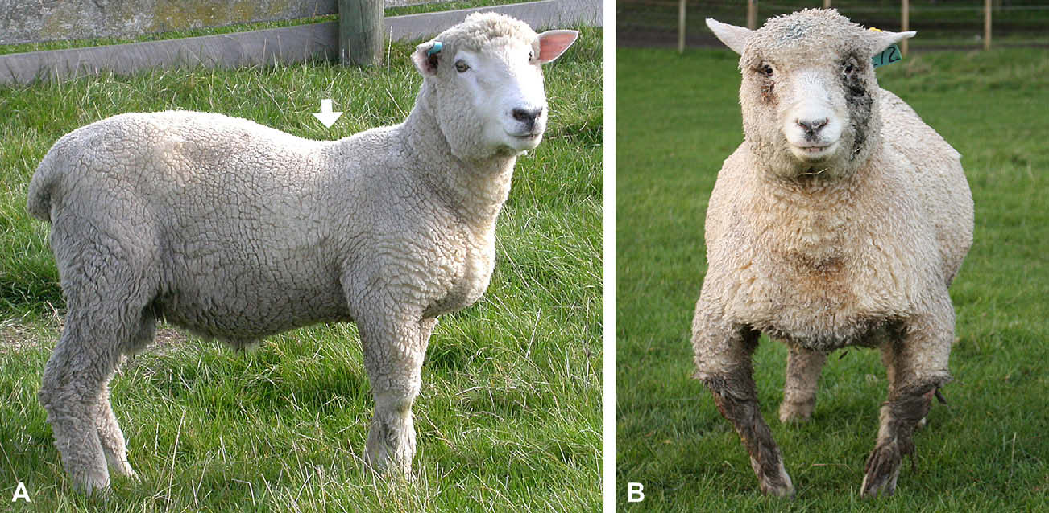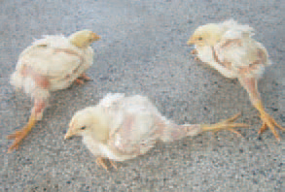

(a) Ricket in sheep (b) slipped tendon (perosis) in poultry

**EVALUATION**

1. What is malnutrition in farm animals?
2. What is nutritional deficiency?
3. Highlight five malnutritional diseases; causes, symptoms and corrections.

**RATION/DIET**

A ration is defined as the feed that is regularly offered to or consumed by the animal. Diets are formulated to meet specific metabolic or physiological functions which include growth, lactation, reproduction, maintenance of pregnancy, egg laying, weaning, fattening etc

**BALANCED RATION**

A balanced ration is the feed containing all essential nutrients in the right or correct and adequate proportion for feeding animals.Components or compositions of a balanced ration include carbohydrate,protein,fats and oil, minerals, vitamins and water.In balancing ration, the nutrients values of the feeding stuffs are known. The nutrient requirement or the standards are also known.

**IMBALANCED RATION**

An imbalanced ration is the feed that does not contain all essential nutrients in the correct and adequate proportion for feeding livestock.

**EVALUATION**

1. What is ration?
2. What is balanced ration?

**There are two categories of balanced ration.**

1. **Maintenance ration:** This is the type of ration that supplies the animal with just the quantity of nutrients that are enough to enable the animal carry on with vital body activities without losing or gaining another substance. In other word, a maintenance ration is the amount of feed needed to prevent an increase or decrease in the weight of the animal. The ration will just be enough to maintain the supplies of energy and protein for all metabolic activities such as respiration, blood circulation, digestion, locomotion, maintenance of body temperature.
2. **Production ration:** is the quantity of ration that can supply the requirement nutrients above the maintenance to enable the animal produce the form of animal product for which the livestock is kept. The production ration can be for meat, growth,milk wool and egg production. The food is supplied in excess of maintenance requirements.

**Categories of farm animals that requires production ratio include:**

1. Lactating animals for milk production.
2. Weaning animals for increase growth.
3. Pregnant animals for maintenance of the foetus.
4. Fattening or finishing animals for extra meat or flesh.
5. Broilers for rapid growth.
6. Layers for egg production.
7. Steaming up or flushing for animal before making to produce more ova.

**Factors to consider when deciding type of ration to feed an animal incudes:**

1. age of the animal
2. palatability of feed stuff
3. familiarity of feed to animal
4. cost of feed
5. physiological status of the animal
6. availability of feed stuff
7. composition of feed nutrient

**EVALUATION**

1. Explain the term ration.
2. Name four classes of livestock feed and list two characteristics of each class.
3. Distinguish between maintenance ration and production ration (WASSCE 1998 question 8)

**CLASS ACTIVITY**

1. a. state eight functions of water in livestock management

b. list eight essential minerals elements required in animal nutrition

c. state four function of mineral elements in the body of farm animals

(WASSCE 1993 question 7)

1. In a tabular form, state:

a. four food nutrient in livestock production.

b. two sources of each food nutrient stated in a above.

c. two functions of each nutrient stated in a above.

(WASSCE 1995 question 7)

1. a. define balanced ration in livestock production.

b. outline the stages involved in the preparation of

i. bone meal ii. Fish meal iii. Cotton seed meal iv. Blood meal

(WASSCE 1996 question 8)

1. a. state six functions of protein in the body of farm animals

b. list five animal source and plant source protein each that can be fed to livestock.

(WASSCE 1999 question 8)

**READING ASSIGNMENT**

PAST QUESTIONS

WASSCE:2007 question 7c, 2012 question 8a, 2013 question 7c, 2014 question 4a, 2017 question 5b

NECOpast question for 2018 question 7d: state three processes that are involved in preparation of silage under anaerobic condition.

**TEXT BOOK**

Essential agricultural science by o.Aiwena pages 329 – 338

**WEEKEND ASSIGNMENT**

1. The deficiency symptom peculiar to Vitamin B in livestock is………

A)night blindness B)sterility C)loss of appetite D) delay in blood clotting.

1. Which of the following is not a symptom of Malnutrition in Livestock………

A) bloat B) night blindess C) milk Fever D) anaemia

1. When an animal is being fed on a ration that does not increase its value but keeps the animal in good health and constant weight, the animal is said to be on ……… ration

A) productionB) maintenance C) concentrate D) balanced.

1. Digestion of protein starts in the ___

A) stomach B) duodenum C) mouth D) small intestine

1. Which of the following classes of nutrient is used mainly for energy production in farm animals? A) Carbohydrates B) protein C) vitamins D) minerals

**THEORY**

1. Write short note on the following

a. maintenance ration

b. production ration

c. balanced ration

d. malnutrition

1. Mention four factors normally considered when deciding the type of feed an animal should be placed on.(WASSCE 2001 question 7)

**WEEK TWO**

**AGRICULTURAL EXTENSION**

Agricultural extension is the process, system or service which assists farmers or farm people through educational procedures in improving farming methods and techniques. In other words, Agricultural extension is the process whereby the beneficial products of research are taken to the farmers and the problems of farmers taken to research institutions for solution.

Agricultural extension is an informal out-of-school voluntary agricultural educational program that involves the spread out dissemination of information on improvement in agriculture from researchers to farmers

**OBJECTIVES OF AGRICULTURAL EXTENSION**

1. To educate farmers and enable them abandon less productive traditional ways of farming for improved and scientific farming techniques
2. To help improve the standard of living of the rural dwellers
3. To help identify proper marketing channel
4. To help farmers access and supervise agricultural loans
5. To link farmers with research institutes
6. To help accelerate the development of rural area

**PRINCIPLES OF AGRICULTURAL EXTENSION**

1. Extension education should start where the people are
2. Gain confidence of your audience
3. Work together with or involve the farmers in creating a programme
4. Extension programmes should meet the need of the participant
5. Programmes must undergo continuous evaluation
6. Programmes should be flexible

Target groups of extension agents incudes and is not restricted to:Commercial farmers, Community development associations, Farmers’ cooperative societies, Fisher men, Bee keepers etc.

**EVALUATION**

1. State seven objectives of agricultural extension.(WASSCE: 2009 question 9b, 2005 question 10a).
2. List five principles of agricultural extension.

**ROLES OR FUNCTIONS OF AGRICULTURAL EXTENSION**

1. It encourages farmers to increase their production of food crops, cash crops and livestock.
2. It teaches improved practices to farmers in the cultivation, rearing and processing of crops and livestock.
3. It helps to collect and collate basic information relating to rural programmes.
4. It acts as an intermediary between farmers and research institutes.
5. It helps to supervise the beneficiaries of agricultural loans.
6. It helps to change people attitude towards their problems.
7. It helps to raise the standard of living of the farmers
8. It helps to identify proper marketing channels for the farmers to sell their products.
9. It enable extension to give necessary assistance to foreign experts visiting states on invitation of government in order to carry out various feasibility studies in various fields of agriculture.
10. It assists in supervising and evaluating agricultural development programmes.

**PROBLEMS FACING AGRICULTURAL EXTENSION**

1. Farm or agricultural inputs are inadequate and often get to the users(farmers) very late.
2. The subject matter specialist(agricultural extension officers) are often not properly involved.
3. Inadequate transport facilities for extension staff.
4. Extension agents are not sufficiently motivated.
5. The supervision of the farmers by the extension agents is weak or poor.
6. Information to farmers is usually delayed and distorted due to poor training of the extension agents.
7. Many agents are ignorant of the tradition and customs of their target communities and often run afoul of their system making it difficult for them to receive audience.
8. Very few extension workers are available to work with too many farmers.
9. Poor facilities for extension communication which limits the scope and efficiency of coverage
10. Target farmers are largely illiterate and find it difficult to follow instructions.
11. Poor or inadequate monitoring of the activities or performance of the extension agents.

**EVALUATION**

1. Enumerate eight functions of an extension agent in the life of a rural farmer/explain eight roles of agricultural extension in the development of agriculture in Nigeria. (WASSCE 1990 question 9, 1993 question 9).
2. Discuss eight problems which an agricultural extension worker can face in the discharge of his duties. (WASSCE 1992 question 9, 2010 question 10c, 2014 question 6b, 1999 question 10).

**EXTENSION METHODS**

Methods used in dissemination new ideas and techniques to farmers are grouped into three classes:

1. Mass media method
2. Individual method
3. Group method

**Mass media method:** This method is used to create awareness and interest in the new ideas and techniques among the majority of the people. In other words, this method enables many people to know about the new innovation. This method involves the use of publications,leaflets,posters,agricultural shows and exhibitions,cinema vans,Newspaper, radio and television,Newsletter,Circular,News Bulletins,Pamphlets,film shows etc.

**Advantages of mass method**

1. Larger audience can be reached
2. Does not necessarily require the presence of an agent
3. It eliminates stress
4. It is not time consuming
5. Print media information last long and can serve as point of reference

**Disadvantages of mass method**

1. It is very expensive to operate
2. Language barrier might hinder effective communication
3. Illiterate farmers might not benefit from this method
4. No effective feedback mechanism is put in place
5. Poor farmers may not get the information since they do not own radios or television set
6. Technological backwardness (no electricity) and bad roads can disallow information from reaching some people.

**Individual Method:** This involves the direct contact between individual farmers and the extension worker. More attention is given to the farmer by the extension worker. Examples of individual method include visits by the extension worker to the home and farm office of the farmer, telephone call, personal letters and text messages.

**Advantages of individual method**

* 1. More attention is given to farmers than any other method
  2. Dissemination of information is more effective
  3. It give room for feedback
  4. Farmers have opportunity to ask questions
  5. It makes adoption of innovation more effective

**Disadvantages of individual method**

* 1. It is time consuming
  2. It is very tedious
  3. It is expensive
  4. It does not give room for reaching larger group of farmers
  5. There may not be enough workers to carry out this task effectively

**Group Method:** This method enables the extension worker to teach the farmers in group. Example of group methods include group discussion,lectures,workshops method demonstration,result demonstration,farm works and excursion,Field trips,symposia,short courses,debates,General meetings,Committee meetings etc.

**Advantages of group method**

1. It enables extension workers reach out to larger group of farmers at a time
2. It saves time
3. It is less tedious
4. It save money
5. Adoption by one can enhance adoption by the others

**Disadvantages of group method**

1. Some farmers might easily discourage others from adopting the innovation.
2. Farmers may not be regular at meetings
3. There may not be enough workers to carry out this task effectively

**EVALUATION**

1. a. What is meant by agricultural extension

b. Discuss briefly how the following can be used in disseminating new ideas and techniques to farmers in Nigeria

* 1. Mass media
  2. Individual method
  3. Group method. (WASSCE 1989 question 9, 2011 question 10a)

1. List three main types of extension teaching method and explain any two of them. (WASSCE 2005 question 10b)

Demonstration involves a practical approach to introducing new innovation to the farmer by practicing the new innovation of the farm land situated where many of the target audience can access to see. The success of the demonstration will push the farmers to want to adopt the new technique

A poster is a pictorial presentation meant to educate or inform the literate audience as the pictures cater for all the needed information.

A bulletin is all written ideas and innovation for literate to read, understand and apply.

Home or farm visit involves one on one or personalized visit to the farmer’s home or farm to establish mutual friendship and acquaint with the farmer and family before giving ideas and information to such a farmer. Rendering of assistance in kind will foster this relationship between the agent and the farmer hence ease adoption of innovation.

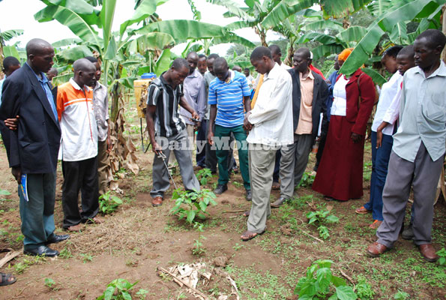

Demonstration exercise showing the proper use of knapsack sprayer

**AGRICULTURAL EXTENSION PROGRAMMES IN WEST AFRICA**

Agricultural extension programmes are the media or channels such as Ministries of Agriculture, Schools of Agriculture, Universities of Agriculture etcthrough which new ideas and techniques are disseminated to rural farmers. In other words, they are bodies or agencies which have extension services unit that can teach and train extension workers on the job approve their daily extension services so that they will be to transfer these innovations to the rural farmers.

Examples of extension Programmes include: Agricultural Development Programme(ADP), Farm Settlement Scheme, Agro-Service Centres, Research Institutes. past and presentgovernment food production programmese.g Operation feed the nation OFN,NAFPP,Green Revolution Programmme etc.

**EVALUATION**

1. State five principles of agricultural extension in Nigeria. (NECO 2018 question 10d).
2. Highlight five agricultural extension programmes in Nigeria.

**AGRICULTURAL EXTENSION OFFICE/WORKER/AGENT**

This is a person who is involved in the dissemination of new ideas and techniques from the research institutes to the farmers.He acts as an intermediary between researchers and the farmers.

**QUALITIES OF EXTENSION OFFICER/WORKER**

1. Extension Officer must be knowledgeable in his field of operation to enable him teach farmers.
2. He must understand the local language of the local community he operate because most farmers are illiterate.
3. He must have interest in what he is doing.
4. He must not easily get annoyed because he will come across various categories of farmers that may ask him foolish questions.
5. He must be persuasive in his operation i.e he should have the ability to always encourage the farmers when introducing new innovations to them.
6. He must have enough materials and financial resources to carry out his duties.

**FUNCTIONS OR ROLES OF AN EXTENSION OFFICER/WORKER/AGENT**

1. He consults and reflects on rural or agricultural development projects
2. He plans and executes farming educational programmes.
3. He organizes and supervises farmers group i.e. meeting, cooperatives and their workers meetings.
4. He liaises with other agencies that may have influence on rural environment and the farmers.
5. He helps to improve the outlook of farmers towards the problems or difficulties.
6. He acts as a connecting link between the researchers and the farming communities.
7. He teaches improved farming practices to farmers.
8. He evaluates agricultural extension programmes and projects.
9. He supervises the utilization of agricultural loans.
10. He conducts or organizes training for farmers.

**PROBLEMS OF AGRICULTURAL EXTENSION OFFICER/WORKER/AGENT**

1. High level of illiteracy among farmers may affect the rate of adopting of new farming techniques.
2. Absence of credit facilities to farmers make them uninterested and prevent the implantation of accepted innovation.
3. Insufficient motivation of the extension workers by way of better remunerations for his effort tends to retard his work.
4. Extension workers do not have adequate resources such as money to travel or enough materials to supply his or her target farmers.
5. Unfavourable attitudes of rural farmers towards government programmes tends to make extension work a bit difficult.
6. Inadequacy of well-trained extension staff make the extension worker have a wider area and more farmers than he can cope with.
7. Language barriers lead to improper dissemination of new innovation by the extension worker.
8. Uncoordinated efforts by government agencies may lead to confusion and rejection by farmers.

**DIFFUSION**

Diffusion is a process of spreading new ideas and information from research station to reach farm families. Diffusion is the movement of new ideas and information from area of higher concentration to area of lower concentration through a medium(extension Officer) and extension method.New ideas and techniques are known as innovations.

**Five Steps or stages of Diffusion process include**

1. Awareness
2. Interest
3. Evaluation
4. Trial
5. Adoption/Rejection/Discontinuation

**Adoption of new innovation** involves the acceptance and practice of new or modern farming technique introduces in the rural area. **This is largely dependent on:**

1. level of education
2. attitude of farmers
3. financial status of farmers
4. size of farm
5. presence of extension workers
6. result of demonstration plot

**Categories of farmers based on adoption of innovation**

* 1. **Innovators:** they introduce new ideas of farming seen in other places to their dwelling. Due to inexperience or error they might suffer losses and can be encouraged by giving expert advice, granting credit facilities, providing and subsidizing farm inputs, granting insurance cover, providing market for sale of produce.
  2. **Early adopters:** are less quick to accepting innovations which might be largely due to some of the aforementioned factors. If percentage of these set is as low as 10% then such innovation has not been uniformly accepted maybe due to hitch during demonstration or the idea is too complex to understand.
  3. **Late adopters:**this group are very conservative and need assurance before accepting new innovations. They usually have the largest percentage in a group.
  4. **Never adopters:** they are extremely conservative and will not accept new innovation no matter the persuasion. If their percentage is usually low

**EVALUATION**

1. An agricultural research organization categorized farmers in village x according to the rate of adoption of new ideas and came up with the following: Innovators 10Early adopters 15Late adopters 70Never adopters 25
2. Calculate the percentage of early adopters and state the implication of this percentage on the extension system.
3. Suggest four ways of encouraging the innovators.
4. State four possible reasons for high number of of late adopters
5. State two merits of the print media as a channel for agricultural extension (WASSCE 2000 question 10)
6. a. Mention four target group of the extension agent

b. Discuss five important qualities of a good extension worker

c. State four functions of an extension worker (WASSCE: 2006 question 10, 2010 question 9c, 2012 question 10c, 2013 question 10c, 2014 question 6a, NECO 2018 question 10e, 2007 question 10).

**GENERAL EVALUATION**

1. a. State two advantages and one disadvantage of each of the following agricultural extension teaching I. Newspaper II. Television III. Demonstration IV. Farm visit V. Home visit

b. Explain the following agricultural extension teaching method I. Poster II. Field trips III. News bulletin IV. Agricultural shows

c. List three agricultural extension programmes in westAfrica. (WASSCE 2008 question 9d and 10c, 2009 question 9c, 10c and 10d, 2012 question 9c).

1. How does agricultural extension affect agricultural production. (WASSCE 2010 question 2ai).

**READING ASSIGNMENT**

1. A. Mention three print and electronic media used in disseminating agricultural extension

B. State four advantage of group method of agricultural extension. (WASSCE 2016 question 6a and b).

1. A. Outline four stages involved in agricultural extension program planning

B. Later two examples of individual method of disseminating agricultural innovations. (NECO 2018 question 9c and d).

**TEXT BOOK**

Essential agricultural science by O.AIwena pages 329 – 338

**WEEKEND ASSIGNMENT**

1. The following are extension methods except _____. A) mass method B) individual method

C) group method D) none of the above

1. Agricultural extension serves as ____ between research institute and farmers A) gap

B) command centers C) bridge D) extension

1. Categories of farmers based on adoption of innovation are the following except____

A) early adopter B) late adopter C) never adopter D) none of the above

1. Television, radio, posters, bulletin are ____ method of extension A) group B) mass C) media D) individual
2. Which of the following grouping of extension method provides feedback A) mass method and individual method B) personal method and mass method C) individual method and group method D) group method and mass method

**THEORY**

1. An outbreak of a strange poultry disease is reported in your community. There is a possibility of the disease dreading to other part of the country
2. Mention the three main extension teaching method that could be used to create awareness among farmers about the disease
3. Which of the main extension teaching method is most appropriate for creating awareness about disease outbreak
4. Give two reasons for your choice in B above
5. Mention three problems that could be encountered in the use of the selected extension teaching method (WASSCE 2011 question 9b).

**WEEK THREE**

**FISH FARMING**

Fish farming (pisciculture) involves raising selected fish species commercially underscientifically controlled conditions in enclosed water bodies such as ponds, lakes etc where they live, feed, breed and are harvested for man’s use. Common fish species reared commercially includes salmon, tilapia, catfish, crab etc.

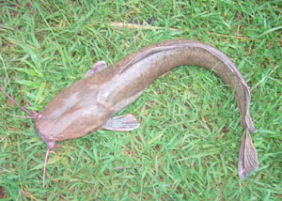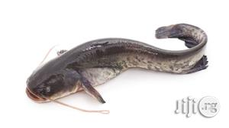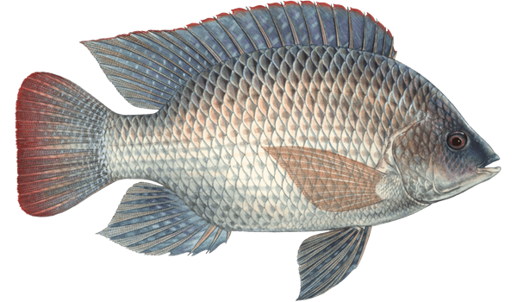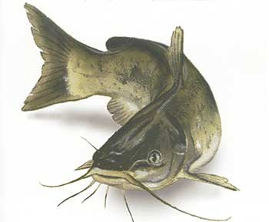

Fishery: This is the study of fish and other aquatic animals. Fish live in water bodies (e.g. ponds, lakes, oceans, seas, rivers), respire with the gills and possess fins for swimming. They are cold blooded animals because their body temperature changes with a change in the environment.

**EVALUATION**

1. Define fishery.
2. Mention five examples of cold blooded animals.

**IMPORTANCE OF FISH FARMING**

1. Food: Fish and other aquatic organisms are used mainly as human food. Fish flesh is regarded highly for containing first class animal proteins, vitamins and many mineral salts and other chemical substances that are needed to keep the human body healthy and strong. The flesh of fish, crabs, prawns and squid is very soft and good to eat. Fish and turtle eggs are also commonly eaten. Fish eggs which are salted and prepared for eating are called caviar.
2. Leather: The skin of cartilaginous fish such as sharks is tough and covered with small, sharp spines. It is sometimes dried and specially treated to produce very special leather called shagreen. Crocodile and turtle skins also make very good leather for handbags, wallets, belts and shoes.
3. Polishing material: Dried fish skin or shagreen is sometimes used like glass-paper for polishing surfaces.
4. Ornaments: The scales of fish are sometimes to make artificial pearls which can be worn as beads. Oysters contain pearls which are polished and worn as jewellery.
5. Soap and medicine: The oils obtained from fish, whales and turtles are used as food and also for the manufacture of medicines and soap. Cod-liver oil is a very popular item consumed by many people as a food supplement.
6. Animal feed: Many fish and parts of fish which are not eaten by humans are processed into fish meal and used in the manufacture of livestock feed.
7. Building: Shells of oysters and periwinkles are sometimes mixed with cement and sand for building houses. The periwinkles make the wall stronger and highly attractive.
8. Glue and fertilizer: Fish bones are also used for the manufacture of glues and fertilizers.
9. Income

**PRESERVATION OF FISH**

This process involves keeping harvested fish long enough to ensure they maintain a very level of freshness before consumption. Preservation prevents spoilage, injury or destruction and this keeps the fish in edible condition for a long time. Harvested fish if not well stored will get spoilt and cause great loss to the farmer hence the need to elongate its shelf life. Preservation can be carried out in any of the following ways:

1. Salting/Curing: Application of salt in the fish which prevents the growth of spoilage organisms should be practiced. Well salted fish can stay long without spoilage provided the fish was originally fresh.
2. Smoking: This is the drying of fish over fire. This reduces the moisture content and improves the taste and flavour of the fish. It also gives colour to the fish. It is necessary that the fish be constantly reheated and aerated and kept away from flies to make it fit for consumption.
3. Canning: This involves the storage of the processed and consumable fish in cans under special conditions for future consumption and sealing the cans so that air cannot passinto them. For example Geisha, Sardine etc.
4. Sun Drying: This involves the drying of fish using the direct heat from sun called solar energy. Here, the fish can only be stored for a short time. It is common in the Northern Nigeria. It is simple and slow. It is not easily practiced in Southern part because of high humidity.
5. Freezing/Refrigeration: This is called chilling. This involves the use of cold storage like deep freezers and refrigerators to store fish over a long time at very low temperature, where bacteria become inactive until the fish are needed. Storage can be done as long as possible provided the system is on.
6. Conversion to feed meal: Parts of fish (especially parts that are damaged or not good for human consumption) are dried and ground into powder known as fish meal. This is used as essential ingredients of livestock feeds. Fish meal is useful to farmers in raising livestock.
7. Roasting: this involves burning fish over naked fire for a short moment.
8. Icing: this involves lacing ice block over harvested fish in a container this method is temporary.
9. Steam cooking: this involves cooking harvested fish over hot steam.
10. Irradiation: this involves the treatment of fish non harmful dosage of ionizing radiation this helps to slow down or halt spoilage by retarding enzymatic action and or destroying microbes.

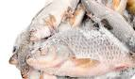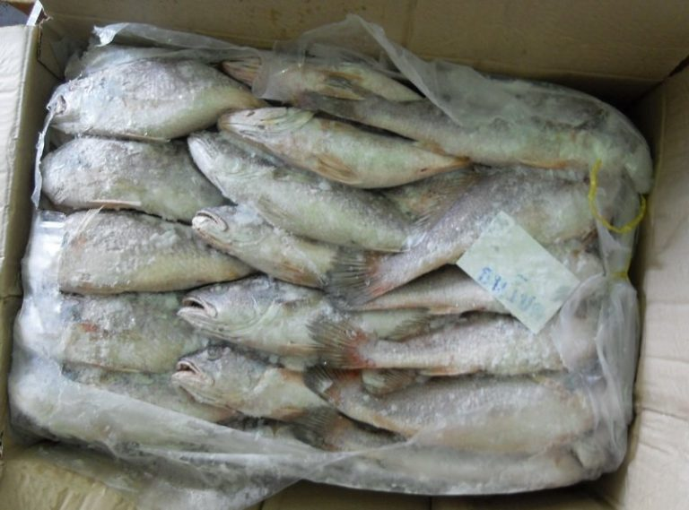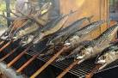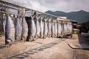

**Some of the aim of preservation is:**

1. To retain the quality and quantity of fish.
2. To increase the shelf life of the food.
3. To develop different types of fish food.
4. To maintain all season supplies.
5. To avoid spoilage caused by micro-organism.

**PROCESSING OF FISH**

Processing is the changing of food material fish from one form to another. It involves the removal of inedible part and changing the fish from one form into a preservable form. These are examples of things removed during processing gut, scales, gills, bones, and fins. By product of fish processing includes fish meal, fish scale, cod liver oil and fish skin.

**EVALUATION**

1. Differentiate between fish processing and preservation.
2. List things to be removed when processing fish.
3. List four aims of processing fish.

**FISH HARVESTING**

Harvesting is the collection of fish from a pond for consumption, preservation or for sale.

**Methods of Fish Harvesting**

Fishing methods involves the use of different techniques or equipments use in harvesting fishes.

1. Netting: This involves the use of nets to catch fish. Examples of nets include gill nets, clap net, trawl net, scoop net, beach seines, drag net, drifting or floating nets, cast nets etc. Nets are woven to various sizes and thickness and are thrown into water to catch fish. Each type is used differently. Nets: These are made from fine cotton or nylon, the thread is lowered into the water. Small weight made of lead is attached to the edges of the net which help them to sink to bottom of the water. When net is pulled up, it encloses many fishes which are then caught between the holes called MESH of the net.
2. Trapping: - This is setting of traps to catch fish. Gears made from ropes or raffia are woven into various sizes for capturing fishes. The traps are set along water courses and any fish that comes into them is trapped. There are many types of fish traps which can be made either from bamboo, canes, raffia, oil palm or coconut palm fronds or wire and wire mesh.
3. Hooks and Lines: - This involves the use of hooks tied to strings then set along water course. The hooks are baited with food to attract the fish.
4. Use of Ultrasonic: - This is an instrument that makes sound in the water to attract fishes. Other means of harvesting like net can later be used to pack them.
5. Electro fishing: - This is the use of electric field connected to the water to make the fishes become electrocuted. It can only be used for total harvesting of fish.
6. Impaling: This involves the use of spears or harpoons or any sharp objects (wounding equipment) to attack and catch big fishes e.g. shark.
7. Pots and Gourds: Some fishermen who fish in ponds and shallow lake, place clay pot and gourds in water to caught the fish when fish enter them.
8. Screen or barriers: Screens made with bamboo, raffia or oil palm fronts are used to enclose portions of shallow water. When fish enters the trap/enclosed areas at high tide, it cannot escape at low tide when water is reduced, hence they are collected.
9. Fishing without equipment: Some aquatic animals can be caught without any kind of fishing equipment. They are picked up by hand having driving to the mud and plants on which they are attached by water current. Examples are periwinkles, oysters, and clams.

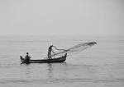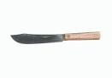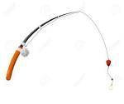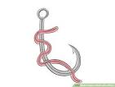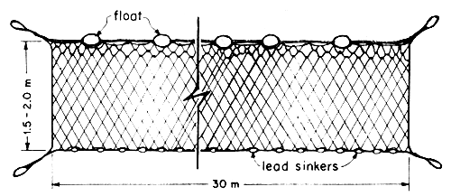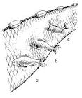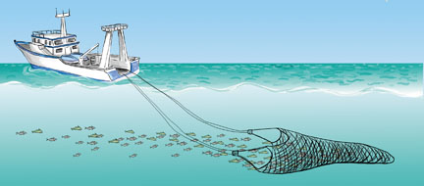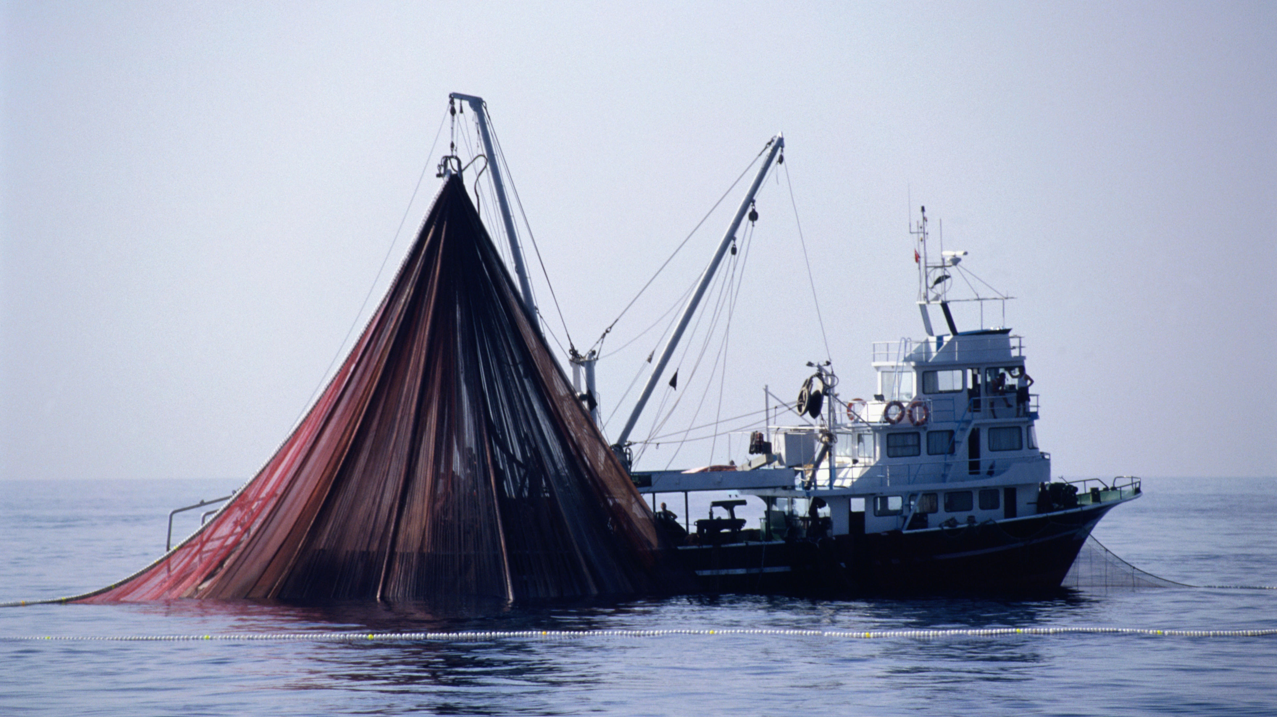

**BASIC LAWS AND REGULATIONS OF FISHERY IN NIGERIA**

Fishery regulations are rules and laws governing the exploitation and other practices of fishery resources.

**The regulations include the following:**

1. **Catch quota:** This is a form of control in which fisherman is allowed to catch a specific quantity of fish or regulating the number of fishermen by issuing them permit or license at a specific amount.
2. **Close season:** This is a regulation in which fishing is not permitted to take place for a given period of time. This helps in making the younger fishes to grow and mature.
3. **Mesh size regulation:** This involves the use of a standard size net or mesh so that only the matured fishes are caught thus leaving the younger ones to grow to adulthood before harvesting.
4. **Population control:**This involves the process of cannibalism where fish types like catfish are made to eat other fish like Tilapia or early harvesting to prevent overpopulation.
5. **Regular stocking:**This is the introduction of compatible species of fish to increase the population of fishes in water.
6. **Prevention of vessels:** No vessels (except canoes) is allowed to fish within the first two (2) nautical miles of the Nigerian Continental Shelf.
7. **Prohibitive use of explosives:** The use of explosives is totally prohibited as this kills young as well as the old fishes.
8. **Ban on the use of poisonous chemicals:** The use of poisonous chemicals like Gammalin 20 is prohibited as it kills both young and old fishes.
9. **Landing tax:** Landing tax is used such that total catch and sizes of fishes are taxed at the site of landing.
10. **Allocation of fishing areas:** Fishing areas are allocated to individual’s fisherman so as to prevent interference with bigger fishing areas.

**GENERAL EVALUATION**

1. What is fishery?
2. What is fish farming?
3. Differentiate between cold and warm blooded animals.
4. Mention eight importance of fish farming.
5. Describe four method of harvesting.
6. Differentiate between fish processing and preservation.
7. List four aims of processing fish.
8. List eight fishery regulations.

**READING ASSIGNMENT**

Essential Agricultural Science by O. A. Iwena Pages 398 - 408

**WEEKEND ASSIGNMENT**

1. Fish eggs which are salted and prepared for eating are called A) Shagreen B) Caviar

C) Canivar D) Smoked egg.

1. Glues and fertilizers are produced by using _____ A) shells of oysters B) Fish bones

C) Scales of fish D) Cod-liver oil.

1. ___ contains pearls which are polished and worn as jewellery.A) Oysters B) Crocodile

C) Turtle D) Lobsters.

1. The skin of sharks are dried and specially treated to produce very special leather called

A) Shannon B) Shagreen C) Shagrey D) Shy green.

1. Processing entails the removal of ___ parts of the fish. A) edible B) inedible C) bone

D) fish

1. Preservation prevents the following except ____A)spoilage B)injury C)processing D) loss.
2. The drying of fish over fire is known as ____ A)smoking B)salting C) freezing D) roasting
3. Which of this is the process of putting in tins with special oils and paste? A) smoking

B) freezing C)canning D) icing.

1. Example of water habitat that can be caught without the use of equipment are ____

A) periwinkle B) turtle C) oyster D) clam.

1. A ___ is anything that attracts the fish into trap set for the fish A) bat B) bait C) food

D) sweet.

**THEORY**

1. a. Describe four method of fish harvesting

b. State four ways of preserving harvested fish

c. Discuss briefly four fishery regulation (WASSCE 1993 question 8, 2009 question 8d,2017 question 6c, 2008 question 8d, 2014 question 5e)

1. a. Give the scientific names of three fish species commonly stocked in a pond (WASSCE 2009 question 7c)

b. Give three reasons why fish farming is important (WASSCE 2013 question 7a)

c. Enumerate two reasons why the use of chemicals is discouraged in fish harvesting (NECO 2018 question 8e)

**WEEK FOUR**

**FISH POND**

A fish pond is an artificial body of water in which fishes are reared for commercial purposes. There are various yes of fish pond. It is a confined body of water where fishes are raised under controlled conditions. Fish can also be raised in plastics, fiber stars and wooden rafts.

There are three types of pond:

1. Earthen pond
2. Concrete pond
3. Plastic pond

**EARTHEN POND**

This involves digging the soil usually clay (25 %clay) to a depth ranging from 0.5- 1.0 m at shallow end and 1.5 - 2.0m at the drain end to raise fish. Pond can be of any shape as long as it is well constructed. However rectangular or square shapes are considered the best. This is usually practicable in swamping environment. This rule away the problem of water maintenance as there is natural flow in and out of water in the pond

**(i) Excavated Pond**

An excavated pond is often built on level terrain and its depth is achieved solely by excavation.  An excavated pond is relatively safe from flood damage, is low maintenance and can be built to expose a minimum water surface area in relation to volume. This is beneficial in areas of high evaporation losses and a limited amount of water supply. Ponds should have gentle slopes on dikes as depicted in the Figure below

[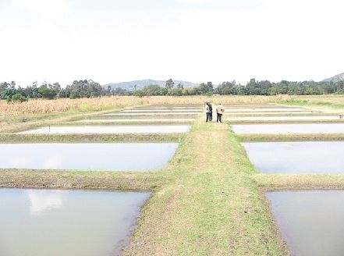](http://www.nafis.go.ke/wp-content/uploads/2011/12/earthen-ponds.jpg)[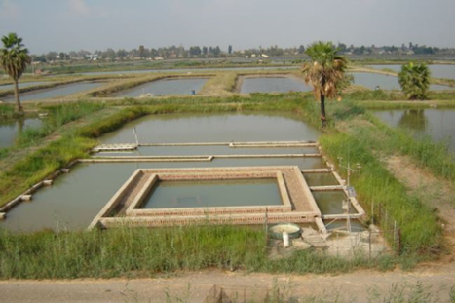](http://fishconsult.org/wp-content/uploads/2011/11/Gravel-filter.jpg)

**(ii) Embankment Pond**

This type of pond is built by creating an embankment or dam used to impound water and is usually constructed in a valley or on gently sloping land. It is not recommended to build an embankment pond on greater than a 4% slope. Less excavation may be needed to build this type of pond.

[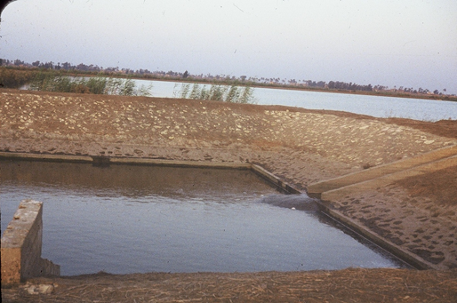](http://fishconsult.org/wp-content/uploads/2011/11/Fish-harvest-catch-pond.jpg)

**2. CONCRETE POND**

Here, 4-5 coaches of blocks are used to construct the pond above the ground level, using cement, sand and gravel in ratio 1:2:4 respectively with water. The pond floor should be well concreted to a thickness between 7.5cm- 10cm. Wall should be plastered to a thickness of 5cm. Water tap should be well connected to allow free flow in and out of water. This particular type has the advantage of you monitoring the hygiene of your fishes.

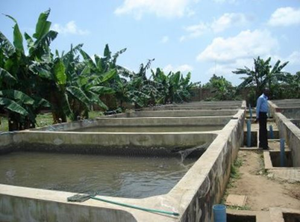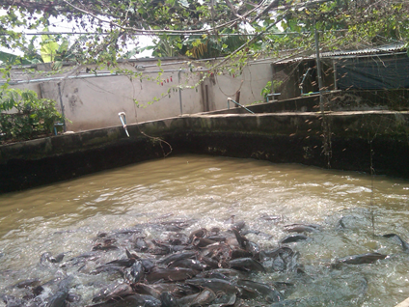

**3. PLASTIC POND**

Pond construction is expensive and this has led many entrants to fish farming in Nigeria to build concrete tanks or to buy plastic tanks as production units. These are smaller units but are believed to be easier to manage as production units. Nigerian farmers have limited land and tank fish farming adapts well to their conditions than larger, more expensive earthen ponds. It is also noted that the quantity of fish harvested from such smaller production units is more easily marketed than harvests from large fish ponds. There are different shapes and sizes of tanks used, as shown below:

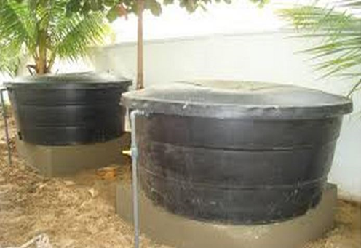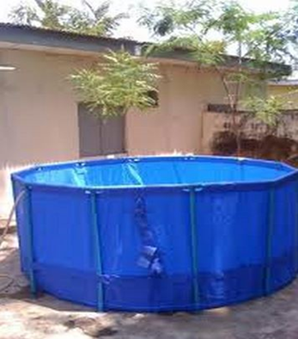

**ESTABLISHMENT OF FISH POND**

**Factors to be considered before the establishment of fish pond**

1. Adequate water supply water could be obtained from boreholes, streams or lakes. Gravity flow water is cheapest and best source. The water must be unpolluted, uncontaminated. Borehole waters can be excellent, but may costly to pump and may require conditioning to remove carbon dioxide and improve oxygen content and temperature levels. Open waters from canals and streams may be polluted or be contaminated from runoff from farm lands or towns. Waters used in aquaculture need to be tested for quality e.g. water with alkalinities less than 30 ppm (CaCO3) will require liming to bring up pH levels close to neutrality (7.0) for best fish production
2. Soil in the area: Soil with enough clay content to hold water. Clay and silty clays are excellent soils for holding water because they stop water from seeping through. Clay should make up at least 20-25% of the soil. The soil should be checked for residual chemicals from previous farm activities which could have effect on the fish health.
3. Vegetation of the area
4. Topography of the area: Topography that allows for economical construction. It directly affects building costs and pond management. Pond should be constructed where enough water can be impounded with the least amount of earth fill. Areas with large shallow water should be avoided because they become too shallow to use during the dry season.
5. Availability of fast growing fish species
6. Availability of supplementary feedstuff
7. Nearness to market: There should be a fish market near-by to allow for high capacity of sale of fish from pond harvests. The market requirement is the first requirement for locating a fish farm. This will further help address issues relating to transportation of the fish to the market.

**STEPS IN ESTABLISHING FISH POND**

1. Site selection: This involves the choice of best site based on necessary conditions like, a piece of land through which a perennial stream flows. Other factors to consider before sitting a fish pond are
2. General survey: Detailed survey of the chosen site should be carried out, especially by extension workers.
3. Clearing and stumping of site: This involves removal of trash, cutting of trees and removal of stumps.
4. Construction of dam: This is usually constructed across the stream. Clay soil should be used for dam construction because of its ability to hold water.

**EVALUATION**

1. Define the following:
2. Site selection
3. General survey
4. a. Which soil is best used for dam construction?

b. State four properties of the soil

1. Construction of core trench: This involves the removal of the soil or excavation. It is positioned at right angle to the dam.
2. Construction of spill way: Spill way is positioned at one end of the dam. It is constructed using a wood and wire-meshed screen.
3. Impoundment of pond: This involves the filling of the pond with water by opening the monk board of the reservoir.
4. Liming: This involves the addition of limestone or calcium carbonate powder to the sides and bottom of the pond to seal pores and prevent water loss.
5. Pond fertilization: This is done by pouring organic fertilizers such as poultry droppings, cow dung or in-organic fertilizers such as N:P:K or super phosphate. Pond fertilization should be done 15 days before stocking pond with water.
6. Pond inoculation: This is the introduction of proper planktons species into the pond. This is done by obtaining some water from a plankton rich pond and pour into a newly fertilized pond.
7. Stocking of pond: This is introduction of the proper baby fish called fingerlings or fries into the pond.

STEPS IN CONSTRUTING A FISH POND

* Choose a suitable site considering nearness to market, road accessibility, topography, soil type (clay), availability of feed supplement etc
* Clear the vegetation on the land
* Mark out pond area
* Dig out pond to required depth (1-2m) ensure pond bottom slops towards outlet to help drainage during harvesting
* Construct drainage system consisting of outlets and ditches
* Construct water inlet at the shallow end.
* Construct pond wall with mixture of clay and sand
* Seal pond bottom with clay
* Grass the embarkment to prevent soil erosion
* Construct duke around the pond mouth to prevent inflow of run-off water.
* Fence pond with net to ward off pests.

**EVALUATION**

1. a. Mention four factors that should be considered when siting a fish pond

b. Explain six ways of maintaining a fish pond (WASSCE 2003 question 7a).

1. Describe the construction of a fish pond (WASSCE 2004 question 8a).
2. State three factors that influences the choice of suitable site for fish (WASSCE 2013 question 7 b).

**MAINTENANCE OF FISH POND**

To ensure the continuous availability of fish in a pond or to maintain high yield of fish, the following activities should be carried out:-

1. Regular feeding: The fish should be fed twice daily from a selected point. Supplementary feeds should be given in sufficient quantity to ensure rapid growth and early maturity of the fish.
2. Constant water supply: The pond should be supplied with water to the fullest. The water should be clean and free of odour.
3. Deweeding: Weeds should be removed from the pond. This allows the dissolution of oxygen, penetration of sunlight to the bottom of the pond for the use of the planktons and preventing the buildup of pests and diseases in the pond.
4. Aeration: Adequate aeration should be provided as it enables oxygen to dissolve in water which is required by fish for respiration. Fish normally comes to the surface due to little or no oxygen in the water in some ponds.
5. Desilting: This is the removal or prevention of silt from entering the water. Desilting promotes easy movement of water, makes the water to be clean and prevent pollution of the water.
6. Control of predators: Predators like snakes or birds should not be given access to the pond as they could eat up the fishes on the pond surface.
7. Disease prevention: Disease should be prevented by adequate feeding, stocking, weeding, manuring of the pond. Sticking to these measures will prevent the attack of diseases.
8. Application of fertilizers: Fertilizers should be applied once in a month as this promotes the growth of planktons in the pond.
9. Regular Harvesting: Fish should be harvested regularly to prevent over population, outbreak of disease and cannibalism.

**EVALUATION**

1. Outline 9 maintenance cultures of ensuring continuous availability of fish in a pond.
2. Outline 5 ways of harvesting fish
3. State 5 ways of preserving fish.
4. List 5 basic laws and regulations of fishery in Nigeria.
5. Explain how each of the following practices can bring about high fish yield from a fish pond
6. Deweeding
7. Desilting
8. Supplement feeding
9. Fetilization (WASSCE 1990 question 8).

**READING ASSIGNMENT**

Study maintenance of a fish pond from essential Agric Science by O.A.Iwena page 257-260

Study maintenance of a fish pond from comprehensive Agricultural science for SSS by OgievaErebor page 182-185.

**WEEKEND ASSIGNMENT**

1. Which of the following are the cheapest methods of preserving fish? a. salting and sun drying b. freezing and chilling c. salting and canning d. smoking and canning.
2. Which of the following is the major function of an air-pump in an aquarium

a. eliminating fish waste from the aquarium b. supplying oxygen to the fish in the aquarium d. eliminating foul odour from the aquarium.

1. In ponds, fish is usually caught with the following except a. trawler b. cast net c. fish trap d.hook and line.
2. Which of the following is the reason for smoking fish? a. removing parasites b. preserving it c.increasing its flavour d. decreasing its flavour.
3. Which of the following pond maintenance operation will ensure adequate supply of oxygen and hygienic conditions for fish in a pond? a. deweeding b. desilting c. fertilization d.eradication of predators

**THEORY**

* 1. Explain five fishery regulations being used in Nigeria.

1. Explain how each of these practices can bring about high yield from a fish pond.

a. deweeding b. desilting. c. supplementary feeding d. fertilization.

1. a. Describe five factors required for establishing a fish pond

b. Enumerate six management practices for maintaining high fish yield (WASSCE 1989 question 7).

**WEEK FIVE**

**ANIMAL IMPROVEMENT**

**CONTENT**

* Meaning of animal improvement
* Aims of Animal improvement
* Process/method of animal improvement

**MEANING OF ANIMAL IMPROVEMENT**

Animal improvement refers to the ways of developing and breeding only those animals that show the greatest merit under consideration such as good feed conversion, growth rate, disease resistance, egg size, etc. It also involves the upgrading of existing (local) breeds as a result of some undesirable characteristics which they possess.

**AIMS OF ANIMAL IMPROVEMENT**

1. To produce animals that can give high yield or products in form of meat, egg, milk etc.
2. To produce animals that can provide high quality of products such as yolk size, shell hardness etc.
3. To produce animals with high feed conversion efficiency.
4. To produce animals with high growth rate.
5. To produce animals with early maturity.
6. To produce animals which can adapt to climatic/environmental conditions.
7. To produce animals that are resistant to parasites and diseases.

**EVALUATION**

1. What is animal improvement?
2. State five aims of animal improvement.

**PROCESS/METHODS OF ANIMAL IMPROVEMENT**

There are three methods or processes of animal improvement. These are;

1. Introduction
2. Selection
3. Breeding

**INTRODUCTION:** Introduction is the bringing into the farm or a country, high quality breeds of livestock with a high productive capacity and other good desirable characteristics from another farm or country. Before the introduction of such animal from another country (exotic breeds), one must be sure breeds possess higher quality characteristics than the local breeds

**Advantages of Introduction**

* 1. Breeds which are not originally present in the home country are introduced
  2. It enhances greater productivity
  3. It leads to the absence of pests and diseases
  4. Breeds may perform better in terms of quality and quantity, if it is able to adapt to local environment.

**Disadvantages of introduction**

1. It may introduce new disease(s) to the new area.
2. It may introduce new pet(s) to the area.
3. It may have the problem of adaptation to the new area.
4. It may not perform maximally

**GENERAL EVALUATION**

1. Define introduction as a method of animal improvement.
2. State three advantages and three disadvantages of introduction.

**READING ASSIGNMENT**

Essential agricultural science by O. A. Iwena Pages 378 – 381.

**SELECTION:** Selection is the process of picking or selecting from a mixed population, those animals with breeding value as parents. Selection is undertaken to maximize genetic gain.

Selection is grouped into two main classes

1. Natural selection: This is the ability of individual animal to survive unfavourable environmental weather conditions and reproduce. Those that are unable to survive die off.
2. Artificial selection: This selection is done by man using his intelligence and influence to select and mate animals in order to increase the number of animals.

There are four types of artificial selection:

1. Mass selection
2. Progeny selection
3. Family selection
4. Pedigree selection

**Advantages of selection**

1. It ensures that only the best naturally available animal is selected
2. Animals with desirable characteristics are selected.
3. Animals from the best breeds are bred for distribution.
4. Animals with undesirable characteristics are dejected and rejected.
5. Selection reduces the spread of diseases.
6. It also reduces the spread of parasites associated with breeding stocks.

**Disadvantages of selection**

1. Selection is tedious and time consuming.
2. It is very costly in terms of time and money.
3. It requires expertise which may not be readily available.
4. It brings about elimination or exclusion of some desirable trait of some parents stocks.
5. No new desirable characteristics are introduced.

**EVALUATION**

1. Define selection as a method of animal improvement.
2. State three advantages and three disadvantages of selection.
3. Briefly explain the types of selection.

**BREEDING:** Breeding involves the development of animals by transferring inherited qualities from parents to offspring. This achieved through mating.

**Types of Breeding**

1. **In-breeding:** this involves the mating of more closely related animals than the average of the population from which they come e.g. the mating of father to daughter, son to mother or brother to sister.
2. **Line-breeding:** It is closely related or similar to in-breeding. It involves the mating of not too closely related animals e.g. mating between cousins.
3. **Cross breeding:** This is the mating of proven quality animals from different breeds. It may lead ta an increase in hybrid viguor e.g. the cross between muturu (resistance to trypanosomiasis) and white Fulani (less resistant to disease) to produce a hybrid which combines two good qualities of two breeds.
4. **Out breeding:** This is the mating of unrelated individual animals within the same breed.

Out breeding is the opposite of in-breeding. It produces offspring with greater vigour and productivity.

**Advantages of Breeding**

1. The crossing or mating of superior animals from two different breeds produce an offspring that is superior to the average of either parent. This is called hybrid vigour or heterosis (cross breeding)
2. Offspring grows more rapidly and is more economical to rear (cross breeding).
3. It results in the production of pure breeds or pure lines (in-breeding).
4. It helps to concentrate and preserve specific qualities in an animal (in-breeding).
5. Offsprings produced can withstand variations within the environment (cross-breeding)

**Disadvantages of Breeding**

1. It may result in in-breeding depression, I.e. a reduction in vigour performance (in-breeding).
2. It can also result in drop in production such as milk, egg, slow growth rate, loss of fertility (in-breeding).
3. It may also result in poor resistance to diseases (in-breeding).

**EVALUATION**

1. Define selection as a method of animal improvement.
2. State three advantages and three disadvantages of selection.
3. Briefly explain the types of selection.

**GENERAL EVALUATION**

1. What is animal improvement?
2. State five aims of animal improvement.
3. Define selection as a method of animal improvement.
4. State three advantages and three disadvantages of selection.
5. Briefly explain the types of selection.
6. State four factors to consider while carrying out artificial insemination.

**READING ASSIGNMENT**

Essential Agricultural Science by O.A. Iwena, pages 378-381

**WEEKEND ASSIGNMENT**

1. All the following are aims of animal improvement except A. Fast growth rate B. Egg size C. Susceptibility to disease D. High feed conversion
2. …is the process of picking or selecting from a mixed population, those animals with breeding value as parents. A. Introduction B. Selection C. Breeding D. Picking
3. The mating of unrelated individual animals within the same breed is called A. Out breeding B. In-breeding C. Line breeding D. Cross breeding
4. Sterility could occur during the practices of the following except A. Artificial insemination B. Castration C. Bad hygiene D. Balanced ration intake
5. ____ is the ability of individual animals to survive unfavourable environmental weather conditions and reproduce. A. Introduction B. Artificial selection C. Natural selection D. Selective selection.

**THEORY**

* 1. (a) What is animal improvement?

(b) State five aims of animal improvement. (WASSCE 2013 question 8 a and b).

1. Write short notes on the four types of artificial selection.
2. Write short note on the following system of breeding
3. In-breeding
4. Line breeding
5. Cross breeding (WASSCE 2000 question 8a).
6. State four objectives of animal improvement programmes in West Africa. (WASSCE 2012 question 8c).

**WEEK SEVEN**

**ARTIFICIAL INSEMINATION**

**CONTENT**

This is the introduction of semen into the reproductive tract of the female by a method other than natural mating. The semen containing the spermatozoa are carefully handled,diluted and stored in freezer at a temperature of -1960C in liquid nitrogen until it is required for use.

**For artificial insemination to succeed**, the following must be ensured

1. Viable spermatozoan must be used.
2. Heat period must been observed.
3. Special handling of spermatozoan because of short life span.
4. Tactical introduction technique.

**Method of collection of semen**

1. Artificial Vagina
2. Massage method
3. Electro-ejaculation.
4. Recovery of semen from the Vagina after service.

**EVALUATION**

1. What is artificial Insemination?
2. State the methods of semen collection.

**Advantages of artificial Insemination**

1. It is easier and less expensive than natural mating since the farmer is saved the expense of maintaining a herd of animals.
2. Easier and cheaper to import semen than whole animal.
3. Larger extent of using one and best male animal’s semen.
4. Handicap of different sizes of female animals is overcome
5. Long use of semen even after death of the male animal.
6. Venereal and infectious diseases associated with mating are easily avoided.
7. Short period of testing with particular semen for research purposes can be achieved.

**Disadvantages of Artificial Insemination**

1. Expertise experience is needful.
2. Expertise is difficult to come by in term of cost and search.
3. Heat period is unpredictable and limiting.
4. Pregnancy rate may be low if handling procedure is adequate (poor timing of oestrus cycle..
5. Inbreeding may occur if only few males are used. That is low level of heterosis.

**GENERAL EVALUATION**

1. State four advantages of Artificial Insemination.
2. State three disadvantages of Artificial Insemination.
3. What is artificial insemination?
4. List four animals on which artificial insemination can be carried out.
5. List a tool that can be used to carry out artificial insemination

**READING ASSIGNMENT**

Read meaning and causes of Artificial Insemination from Essential Agric Science by O. A. Iwena page 381 - 382

**WEEKEND ASSIGNMENT**

1. Which of the following statements is true of a pig which has only one testis? A)it will be sterile b)it can still produce viable sperm c)all the spermatozoa will be dead d)it will not be able to mate a sow
2. How can the offspring of a bull continue to be produced long after its death? By a)collecting the semen of the offspring for use in artificial insemination b)crossing the male and the female offspring c)preserving the body of the dead animal d)using the preserved semen for artificial insemination.
3. Which of these is not a method of collecting semen? A)reseeding b)Artificial Vaginac)Massage method d)Electro-ejaculation e)Recovery of semen from the Vagina after service.
4. Cost and ease of importing is considerably reduced when buying the following inputs

a)Foreign bull b) Tractor c) Semen d) Sprinkler

1. Sterility could occur during the practices of the following except a) artificial insemination b)castration c) bad hygiene d) balanced ration intake

**THEORY**

1. a. What is artificial Insemination?

b. State three methods of collecting semen from a proven male for use in artificial insemination (WASSCE 2000 question 8b).

2 a. State six advantages of Artificial Insemination.

b. State three disadvantages of Artificial Insemination.

**WEEK EIGHT AND NINE**

**AGRICULTURAL FINANCING**

**Meaning of Agricultural Finance**

Agricultural finance is the act of acquisition and use of capital in agribusiness. It deals with the demand for and supply of fund order to carry out various projects on the field of agriculture. The main objective of financing is to increase and other productive factors, stocks available to farmers so as to expand production.

**Meaning of Agricultural Credit**

Agricultural credit refers to a refundable loan granted to a farmer to enable him improve in his farming activities. it can also be defined as loan granted to a farmer by credit lending agencies for agricultural purposes.

**Types of Farm Credit**

There are three major classes of farm credit:

1. **Short term credit:** This is a productive credit which the borrower is expected to pay back within a year. It may be used to purchase items that can easily be used up with optimum output. Examples are improved seeds, fertilizers, chemicals, fuel etc.
2. **Medium term credit**: This is the type of credit which the borrower is expected to pay back within a period of two to five years. It can be used to purchase items that can be turned around or used within the time frame and yield high profit. Examples, purchase light duty machine or simple farm implement, breeding livestock, building housing units for livestock, erecting farm structures etc.
3. **Long term credit:** This is a productive credit which is repayable within a period of five to twenty years. It attract highest amount of money compared to short and medium term credit. It can be used to purchase costly fixed assets such as farm buildings, land, heavy duty machines etc.

**Importance/ Significance of Agricultural Credit**

* 1. It enables the farmer to acquire necessary modern farm inputs to improve and increase their efficiencies.
  2. It helps farmers to maintain large land area.
  3. It enables farmers to acquire storage and processing facilities.
  4. It improves the standard of farmers.
  5. It helps farmer to take care of any prevailing condition in the farm such as pest and disease control.
  6. It helps the farmer to insure their farms against hazards surrounding farming.

**AGRICULTURAL SUBSIDY**

This is a non-refundable aid granted to farmers to enable and encourage them in their production. It also refers to a discount given to farmers by agencies usually government agencies in the course of farmer, purchasing agricultural inputs such as chemicals, fertilizers, improved seeds.

**SOURCES OF AGRICULTURAL FINANCING OR FARM CREDITS**

1. **Agricultural banks:** Example Nigerian Agricultural and Co-operative Bank (NACB) established solely to grant loans to potential farmers.
2. **Commercial Bank:** Have departments that take care of loans given to farmers. Example of such banks are United Bank of Africa (UBA), Union Bank PLC, Wema Bank PLC etc
3. **Cooperative society:** Members pool their resources together and whoever is interested in getting loans can obtain it from the society.
4. **Credit and thrift society:** Members contribute money in which they use in financing their farming business.
5. **Self-financing:** Money saved by individual to finance agricultural business.
6. **Individuals:** Money borrowed from friends, relatives etc to finance agricultural business.
7. **Money lenders:** People who lend money to farmers to enable them produce. They charge high interest rate.
8. **Government agencies and government:** These are department in government establishment or ministries responsible for granting credit to potential farmers.
9. **Non-governmental organization:** These are bodies set up by individuals or group of people with the aim of rendering services or financial assistance to farmers.

**Problems associated with farm credits**

Reason why farmers find it difficult to procure loans from banks includes the following:

1. High interest rate: The percentage of interest charged on principal sum by banks is usually high and this discourages borrowing.
2. Lack of collateral security. Most farmers do not have items of value that they can present as collateral to secure loans from financial institutions
3. High level of loan defaulters. Farmers default in paying back the loan as at when due.
4. Diversion of loan. Some farmers divert the loan to areas for which the loans are not originally meant for.
5. Lack of proper farm records and Accounts. Most farmers lack accurate farm records and account that can lead be used to access their credit worthiness.
6. Unpredictable climate which can lead to crop failure. Due to various climate factors, farmers may invest so much to their farms and have very low yield.
7. Lack of insurance policy. Most farmers do not insure their farms against unforeseen occurrences such as fire outbreak.
8. Long Gestation period of plantation crops.

**EVALUATION**

1. What is agricultural finance?
2. What is agricultural credit?
3. State three type of farm credit.
4. Outline 5 significance of agricultural credit. What is interest?
5. Outline 5 reasons why farmers fail to procure loans from banks.

**WEEKEND ASSIGNMENT**

1. Financial assistance from the government to the farmer is usually in the following forms except (a) loan (b) credit (c) tax (d) subsidy.
2. The assistance given to a farmer by the government in form of reduction in price is a, input b, credit c, loan d, subsidy.
3. The following are sources of agricultural credit except a) agricultural bank b) cooperative society c) commercial d) mortgage bank.
4. Short term credit can be used to purchase the following except a) improved seed b) fertilizer c) herbicides d) tractor.
5. Investment with long life span in agricultural economics are otherwise known as a) labour b) capital c) profit d) savings deposit.

**THEORY**

1. a. Explain the meaning of agricultural finance and agricultural credit

b. Name six sources of agricultural credit available to small scale farmers

c. Mention six problems associated with agricultural credit WASSCE 1990 question 10, 2014 question 10b

1. a. Briefly explain each of the following types of credit in agricultural production
2. Short term credit
3. Medium term credit
4. Long term credit

b. List four sources of agricultural credit

c. Explain briefly four reasons why farmers find it difficult to loans from banks (WASSCE 1997 question 9).

**CLASS ACTIVITY**

1. a. Briefly explain (a) Agricultural finance (b) Agricultural credit

b. Explain four significance of agricultural finance

c. Mention one problem farmers encounter in obtaining credit from the following credit sources

1. Commercial banks
2. Community banks
3. Money lenders
4. Family sources (WASSCE 2001 question 10).
5. a. Explain the term farm credit

b. List five sources of farm credit (WASSCE 2011 question 9a).

1. Distinguish between the terms loan and subsidy as used in agricultural financing (WASSCE 2012 question 9a).
2. A farmer borrowed 6kg of maize during the dry season at N150/kg. Six months later, he paid back with 8kg of maize at N125/kg. What will be the interest charged on the maize borrowed by the farmer? (NECO 2018 question 10a).

**WEEK TEN**

**AGRICULTURAL INSURANCE**

**CONTENT**

* Meaning of Agricultural Insurance
* Importance of Agricultural Insurance
* Various Agricultural Risks
* Types of Insurance Policies for Agricultural Production
* Problems of Agricultural Insurance

**MEANING OF AGRICULTURAL INSURANCE**

Agricultural insurance is the insurance policy which provides compensation to famers for losses suffered. For example, the loss of their crops due to natural disasters such as hail, drought and floods or the loss of revenue due to declines in the prices of agricultural commodities.

Insurance is one of the tools that farmers and other stakeholders can use to manage risks that are too large for them to bear/manage on their own. Part of the risk is transferred to another, who takes it in return for a fee (or premium)

**IMPORTANCE OF AGRICULTURAL INSURANCE**

1. Agricultural insurance plays an important role in simulating investment in agriculture and in stabilizing famers' income.
2. Insurance can assist farmers in accessing new opportunities by improving their ability to borrow either in cash or in kind as credit facilities. In doing so, farmers may potentially experience safer and possible higher returns
3. Another area where insurance is of relevance is in improving agricultural technology. With the security of insurance, the farmers might be more willing to take a chance with efficient technology as his risks are now being shared.
4. It stimulates investment in agriculture
5. Help to stabilize farmers income
6. Assist farmers in accessing new opportunities By improving their ability to borrow.
7. It helps to improves the development new technology in agriculture.
8. It boosts farmers willingness to take chance with efficient technology.

**VARIOUS AGRICULTURAL RISKS**

1. Human or personal risk: The farm operator can get health problems or even die.
2. Asset risk: This includes theft, fire and other damage or loss.
3. Production or yield risk: Most of the time the weather is responsible, but it also includes risks like plant and animal diseases.
4. Price risk: risk resulting from fall in price after production modification has been done
5. Institutional risk: this is associated with policy changes which can have negative impact on production and farm revenue
6. Financial risk: this refers to the possibility of increase in interest of a mortgage, insufficient liquidity and loss of equity

**EVALUATION**

1. Define agricultural insurance.
2. State three importance of agricultural insurance
3. Briefly explain five agricultural risks

**TYPES OF INSURANCE POLICIES FOR AGRICULTURAL PRODUCTION**

1. **Specific enterprise insurance:** this is an insurance policy that covers a particular farming enterprise. It protects the farmer against any form of loss due to disasters or calamity. It is further divided into

* **Crop insurance:** this is purchased by crop farmers, ranchers and anyone whose enterprise is based on crop product to protect themselves against loss of crop due to natural disasters such as flood, drought, and convulsion of nature (earth quakes, volcanic eruptions, pest and disease) or from malicious damages. The policy maybe to protect against a particular peril or collection of perils or all.
* **Livestock insurance:** to protect animal farmers and their allies against foreseeable and unforeseen disasters. It also gives the insurance industry the opportunity to make meaningful entry into the rural areas.

1. **Farmer’s vehicle insurance:** this Insurance covers machineries used on the farm such as tractors, harvesters, pumps, wind mill etc. The premium rates in some countries are determined by motor insurance tariff.
2. **Life assurance:** this is insuring human life in the event of death, accidents, retirement or disability. The policy holders are assured that in the event of any of the above, financial compensation will be paid to their dependents or to them as the case maybe.

**Insurance premium**: is the consideration (a fee paid at regular interval) given by the insured (farmer) in return for the insurer’s (insurance company) undertaking to compensate the insured in the manner agreed on the happening of a specified occurrence.

**Indemnity:** this is the mode of compensation that the insurer employs to (honor the agreement they had) put the insured back to his position before the loss.

**PROBLEM OF AGRICULTURAL INSURANCE**

1. Lack of skilled personnel both at managerial and operational level
2. Lack of awareness of benefit of insurance in other to convince farmers of the benefits.
3. Uncertain weather conditions
4. Limited capacity of insurance businesses to assume risks
5. Illiteracy and conservatism of farmers in rural areas.

**EVALUATION**

1. Differentiate between the following a) Premium b) Indemnity
2. State different forms of agricultural insurance policy
3. State five problems of agricultural insurance.

**GENERAL EVALUATION**

1. State three importance of agricultural insurance.
2. Explain briefly five risks of agricultural insurance.
3. State four forms of agricultural insurance policy.

**READING ASSIGNMENT**

Essential agricultural science by o.AIwena pages 459-463.

**WEEKEND ASSIGNMENT**

1. ___ is the mechanism by which insurer provides financial compensation to the insured in an attempt to place the insured back to the position he was before the loss A. Premium B. Loan C. Indemnity D. Subsidy
2. All these are forms of agricultural insurance policy except A. Crop insurance B. Livestock insurance C. Marine insurance D. Motor vehicle insurance
3. ___ deals with the insurance of human life either in death, retirement or disability. A. Crop insurance B. Specific enterprise insurance C. Livestock insurance D. Life assurance
4. ___ is the consideration given by the insured in return for the insurer’s undertaking to indemnify the insured in the manner agreed on the happening of a specified occurrence. A. Premium B. Loan C. Indemnity D. Subsidy
5. Agricultural risk includes the following except A. Personal risk B. Yield risk C. Price risk

D. Premium risk

**THEORY**

1. a. What is agricultural insurance

b. Explain briefly the following types of insurance policies for agricultural production

1. Specific enterprise insurance
2. Life assurance
3. Fire disaster insurance (WASSCE 2016 question 5 a and b).
4. Give four reasons why agricultural insurance is important (WASSCE 2017 question 6b).